## Project Report On

**Steel Fabrication Order Management System**

## INDEX

|  |  |  |
| --- | --- | --- |
| **Sr. No** | **Title** | **Page No** |
| 1 | Introduction | 6 |
| 2 | Project Features | 8 |
| 3 | Feasibility and software Requirements | 11 |
| 4 | Database Description | 15 |
| 5 | User Interface | 13 |
| 6 | Testing | 18 |
| 7 | Conclusion | 19 |
| 9 | Bibliography | 20 |

**Chapter 1: INTRODUCTION**

The web based “Steel fabrication Order management system” project is an attempt to simulate the basic concepts of order management system. The system enables the customer to do the things such as view all available products, products by category wise distribution. Then user can place the order, delivery agent will get the order details and it will be delivered to the customer at their residence. Users can request for customized product with their own requirements and budget. The system provides facility that enables users to view details about products without login. But if user want to place the order, then it is required to login first. User can view all available products with its detailed description, reviews and ratings. User can choose particular product. The system checks for the availability of quantity of product. If the product is available then the system allows the customer to select product and place order. To order a product the system asks the customer to enter his details such as first name, last name, city, street, landmark, state, pin, phone number, etc.

### Purpose

Purpose of Order Management System for Steel Fabrication Factory project is that the system will be used to fulfil the need of people who wants to opt for the ordering the steel furniture online. Actually, it is not easy to do this process manually because it would become very hectic. Hence it is recommended to automate the process by developing the relevant software as the world is moving from manual working to information and technology era where computerization becomes important in all part of life.

### Scope

1. Order Management System for Steel Fabrication Factory is we-based application that allows the admin to handle all the activities online quickly.
2. So, the aim of the project is to provide product tocustomers. The customer can choose the products from category and place the order. Users can request for customized product of their own requirements and budget. Staff then can contact to user with the details provided by user at login time.
3. Staff will arrange the products as per the order and make it available for collection.
4. Once the order is ready, delivery agent will collect the products and it will be delivered to the customer at their residence.

### SYSTEM ANALYSIS AND DESIGN

System analysis is the performance management and documentation of activities late to the life cycle phase of any software namely:

1. The Study Phase
2. The Design Phase
3. The Development Phase
4. The Implementation Phase
5. The Testing Phase

Software analysis start with a preliminary analysis and later switches on to detailed one. During the preliminary analysis the Analyst taken a quick look at what is needed and whether the cost benefits. Detailed analysis studies in depth all the cornered factor, which build and strengthens the software

## Chapter 2: PROJECT FEATURES

### Admin module

Admin is the main role in overall system. Admin can login into the system using credential where admin credential was already stored into the database.

After successful login into admin dashboard, there are variousoperation that admin can do are mention below –

1. View customer: Admin are able to view the list of the customer who are already registered into the system. Customer data is store in database so admin can fetch those data to view the list of customers.
2. Add remove staff: Admin can add staff by giving particular role also admin are able to delete it from system.
3. View feedback: Admin can view feedback which are given by customer on products after purchasing.

### Manager module

Like admin, manager can log in into the system with the credentials stored into the database. Manager carries out the most of operations on the owner side.Manager can perform following functionalities mention below:

1. Manage products: Manager can add products into the system with all necessary details. As the products are managed category wise, manager can add distinct categories first and then products under that specific category. Manager can also update products by changing price of product or available quantity of product.
2. Manage delivery: Manager is able to see all the orders. After placing order by user, manager assign that order to the particular delivery agent. That order is visible to that delivery agent’s dashboard with details.
3. View feedback: Manager can view feedbacks and ratings given by customer on products after purchasing. Manager can review and analyse those feedbacks.
4. View order customization: Manager can review the customised orders which users have requested, and contact to that specific user from the contact details given at login time.

### User module

User can login into the system, or even without login user can see product lists, detailed description of products, review and ratings of product. Even without login user can check all available products. But to place an order user needs to login first into system.

Registration and creation of user profile

The system shall require a user to register, in order to carry out process to place order. For registration it will ask the user for the following information first name, last name, city, street, landmark, state, pin, phone number, email and password. The system will automatically generate user’s profile.

### Making Order

After registration user's credential is saved in databases and using credential user can login into the system. For placing an order user must do login first otherwise system will not allow user to place order.

After login into system successfully now user is able to place an order. First user needs to search the available product or user can search product by category, one more option is available that user can select product and customize it according their need.

If user want to place order of multiple products, then first user select one item and move it to cart using 'add to cart' button, after adding it into cart now user can go for another product and user can add multiple products into add.

After adding products into cart, cart dashboard will show all the products, product quantity and total price. Now user can place order by selecting payment method.

View Order History: The system shall allow a user to view all information about his previous orders. In history system shows previous product, delivery status, etc.

### Delivery Agent

Account Delivery agent is another important role in this system. The main role of the delivery agent is to deliver the product on mention address and update the status of delivery. Delivery agent has functionalities mentioned as below:

1. Receive order: Delivery agent received the order and do a job of delivering the product in time.
2. Track order: Tracking status of the product during delivery is updated by delivery agent. Tracking status like 'product arrive, 'on the way', 'delivered', etc. Users get to see these status on his/her side.
3. Verify payment: Delivery agent need to verify the payment details like whether payment is already done or need to be collect at the time of delivery.
4. Update order status: After delivering the order successfully, delivery agent needs to update the status as 'delivered'.

## Chapter 3: FEASIBILITY AND SOFTWARE REQUIREMENTS

Feasibility study is a test of a proposed system according to work ability, impact on the organization’s ability to meet user needs and effective use of resources. Feasibility study is performed by, considering the factors such as development cost, operating cost, response time, development time, accuracy and reliability. Not all requested projects are feasible. We compare the proposed system with the existing system. In feasibility study we develop more than one way to solve the existing system problems. From this we can select the feasible one and then we prepare detailed description our Feasibility study includes studying the available general purpose.

### Software Required for Development :

Module 1: Database Design –

* + 1. MySQL-for database requirement.

Module 2: Front End –

1.HTML,CSS,JavaScript,React js.

Module 3: Back End –

1. Eclipse IDE(Any IDE),Spring tool suite, tomcat server.

### Methodology:

Waterfall model is used to carry out the project. It is

simplest process model. Which states the software development phase organized in linear order.

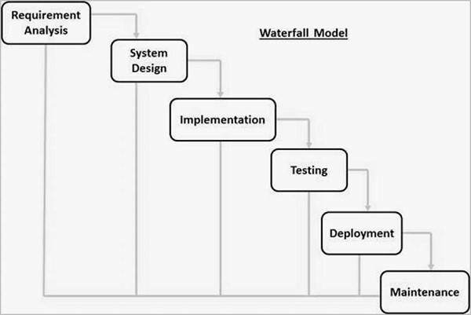

### Fig 1:Waterfall Model

**Fig 1: Waterfall Model**

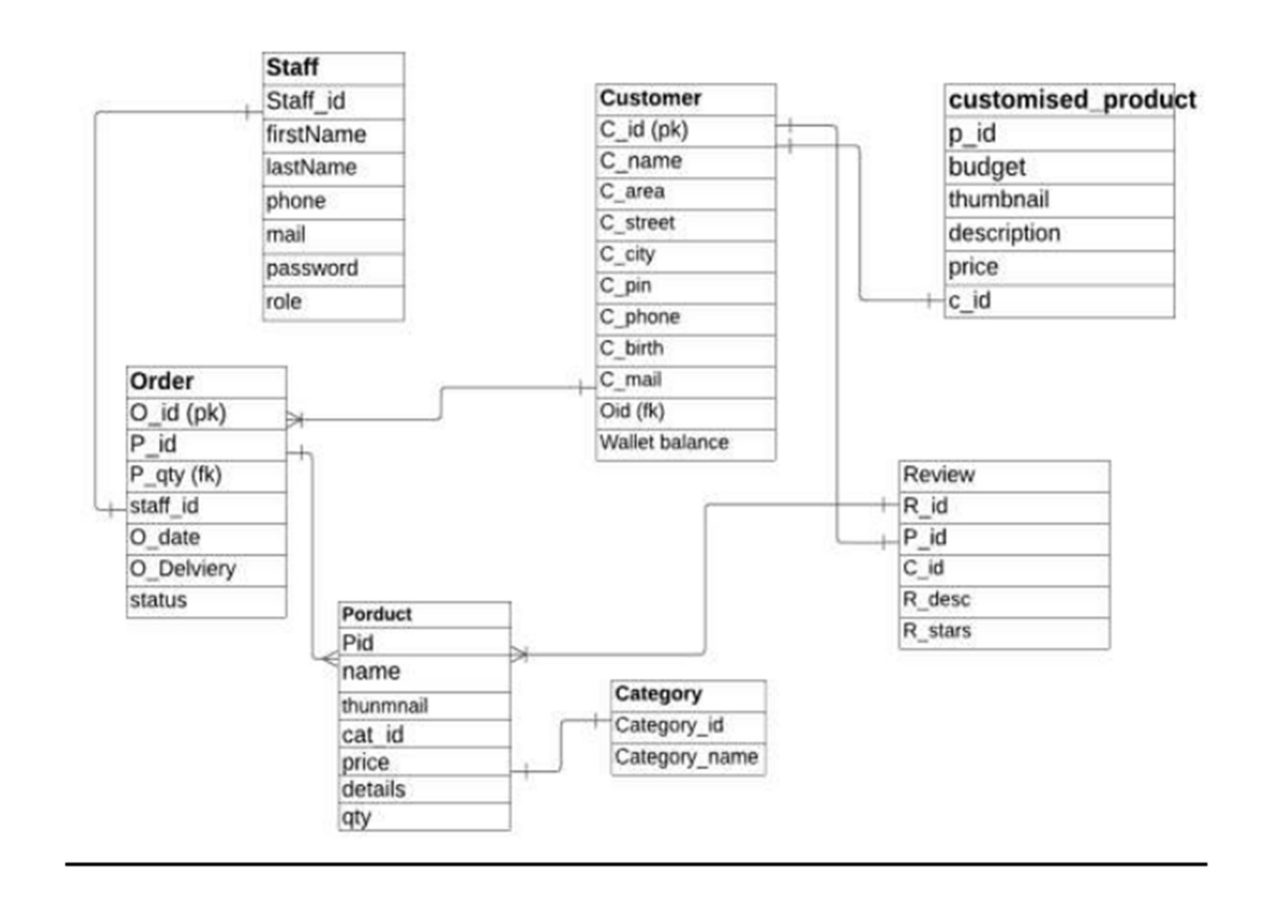

**Fig 2: E-R Diagram**

**Chapter 4: DATABASE DESCRIPTION**

The following table structures depict the database design.

### Table1: Customer

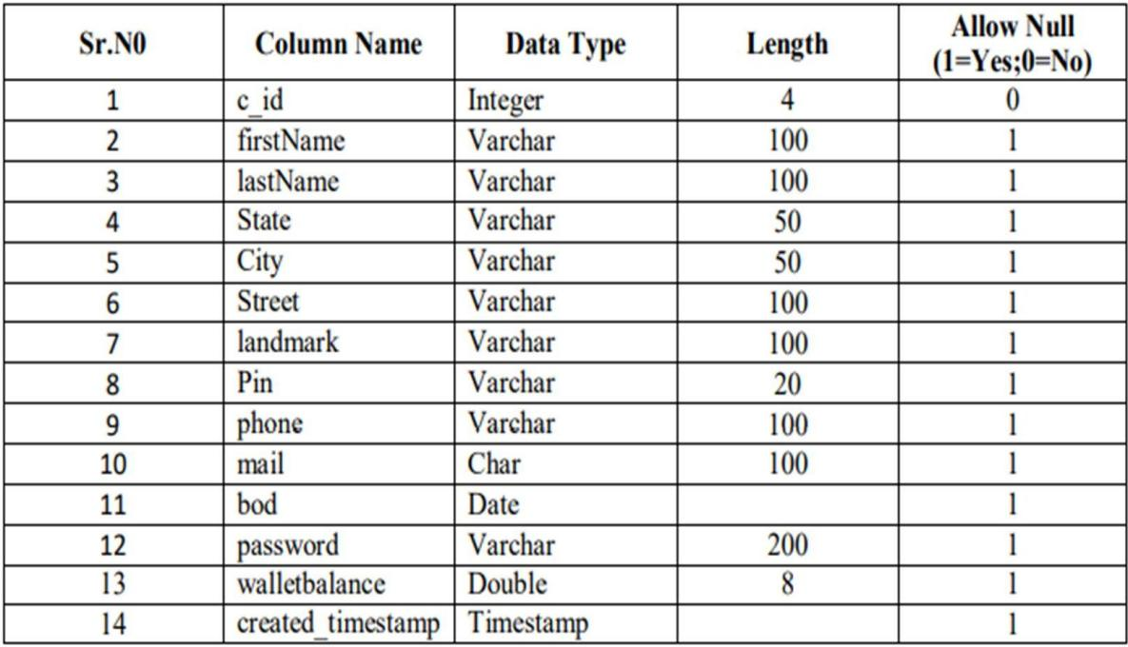

* **Table2: Category**

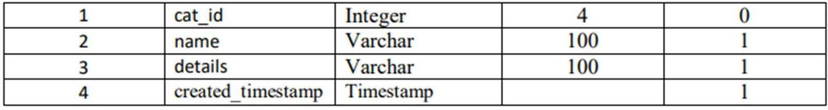

* **Table3: Products**

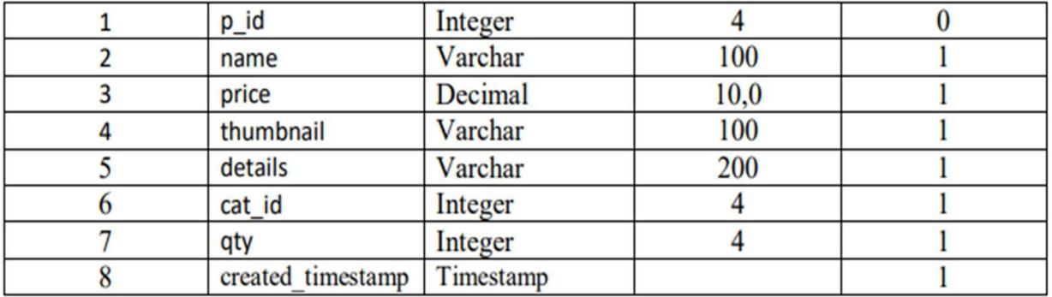

* **Table4: Review**

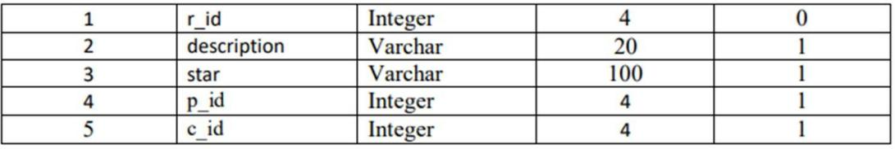

* **Table5: Staff**

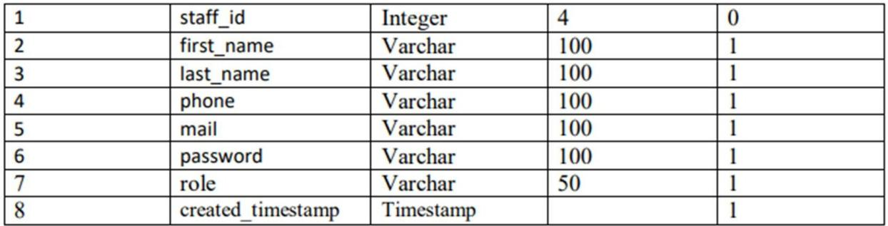

* **Table6: User Order**

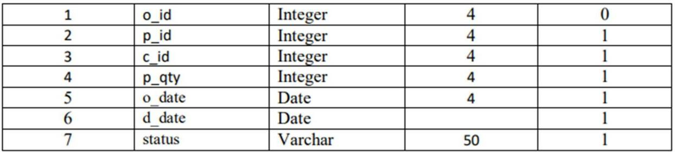

* **Table 7: Customised Products**

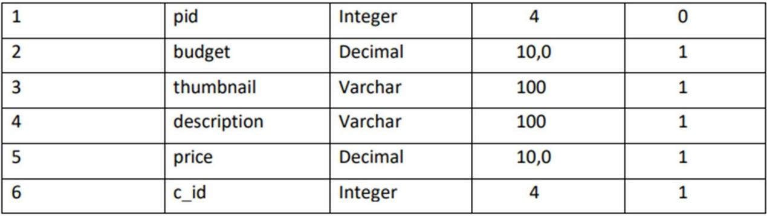

**Chapter 5: USER INTERFACE**

**Admin Home**

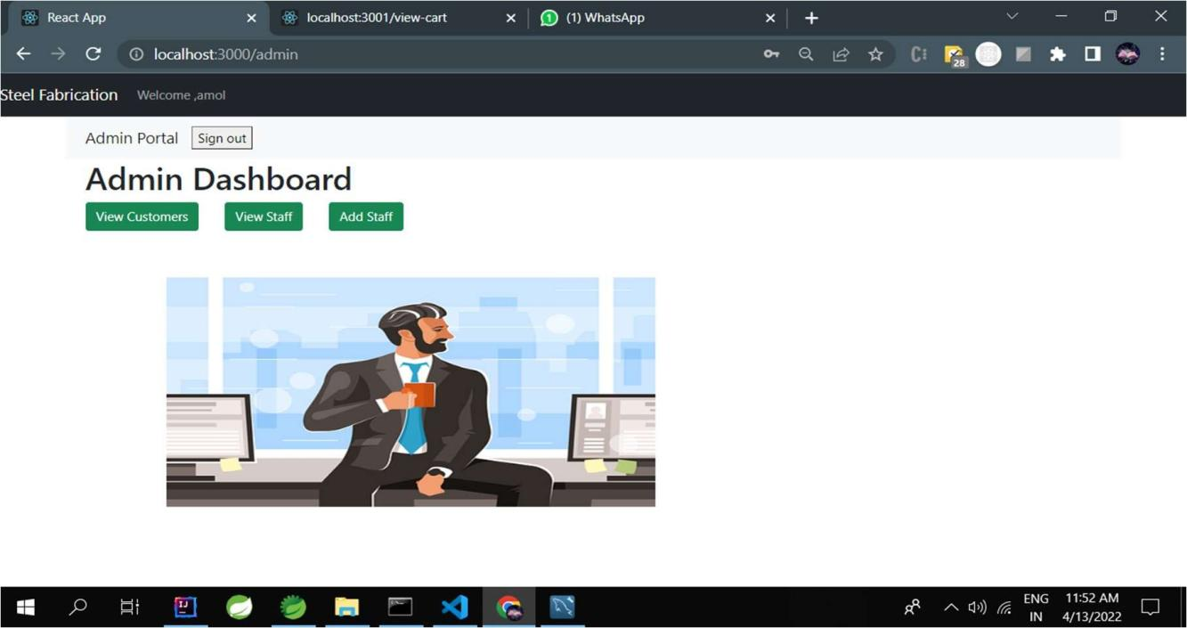

**View Staff**

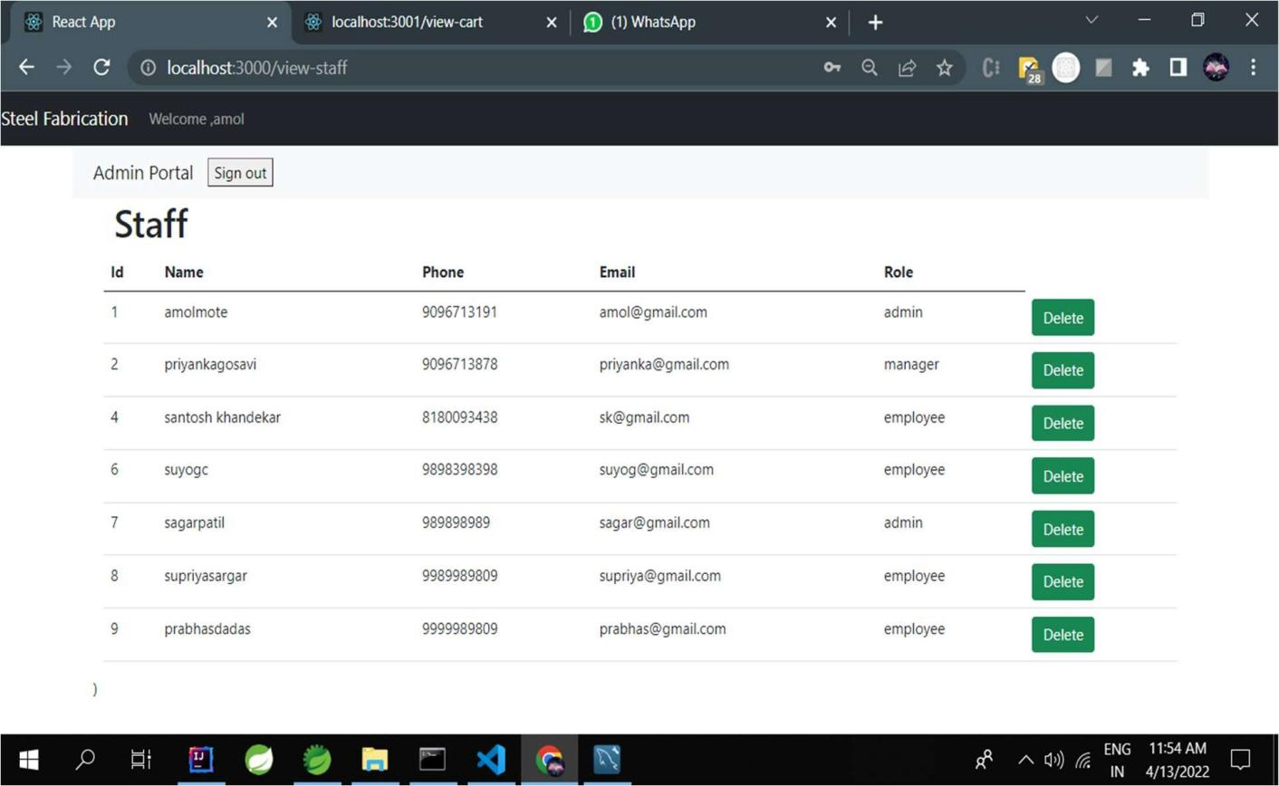

**Customer Home Page**

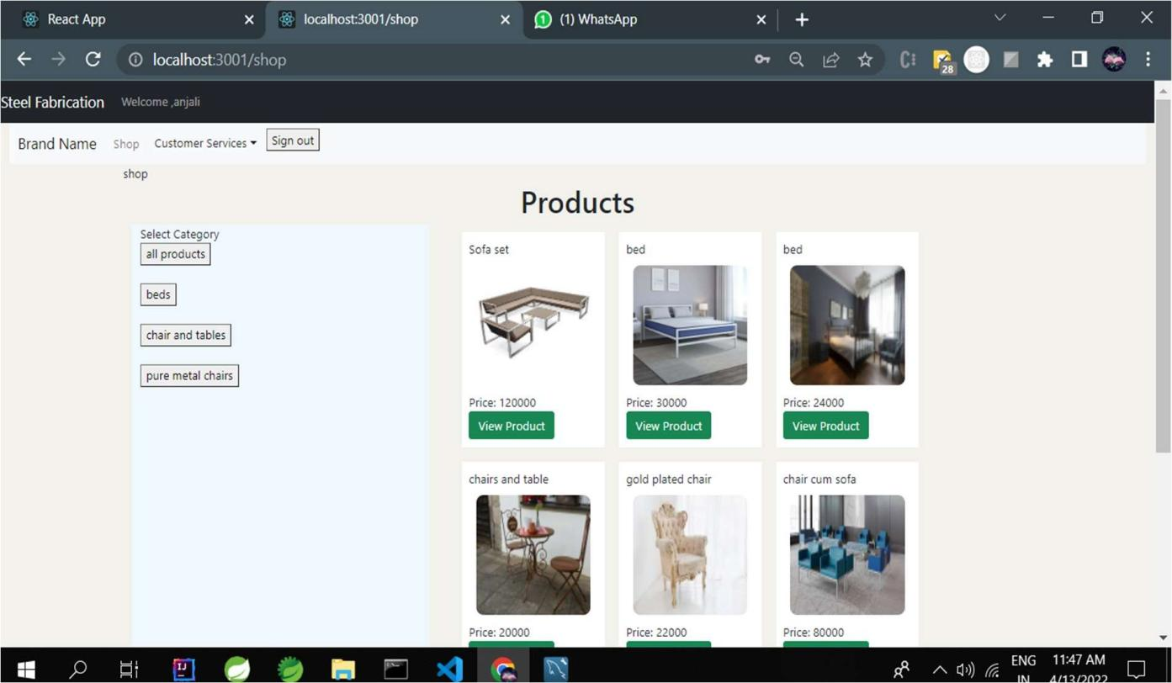

**Manager View Products**

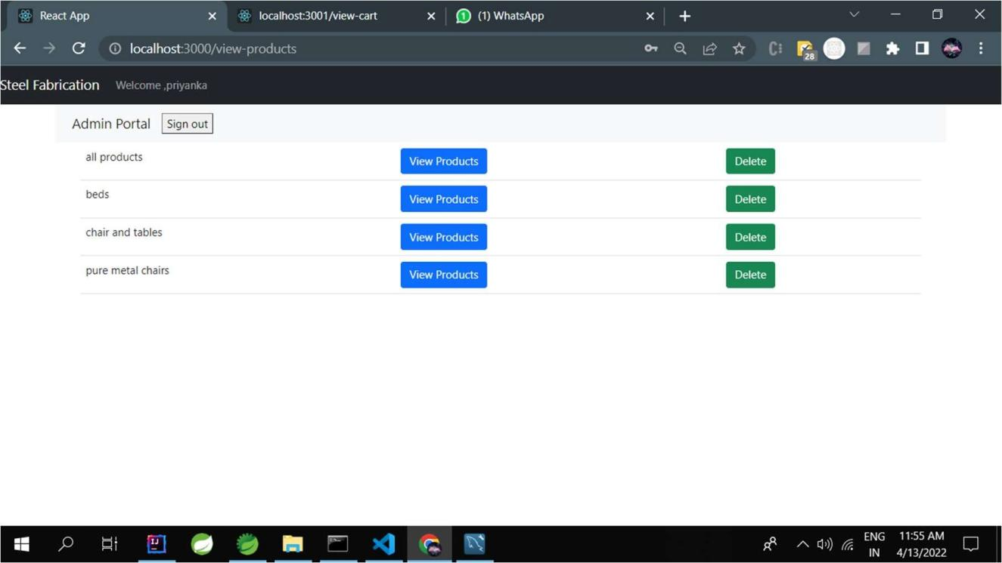

**Manager Home Page**

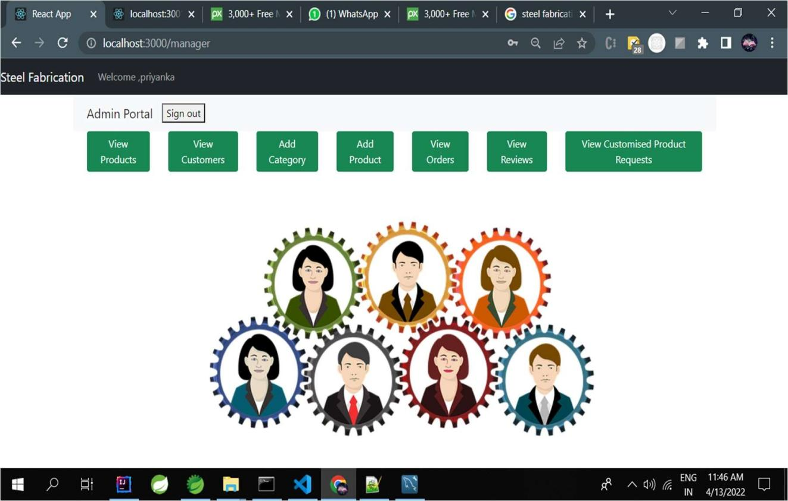

**Chapter 6 : Testing**

**GENERAL TESTING**

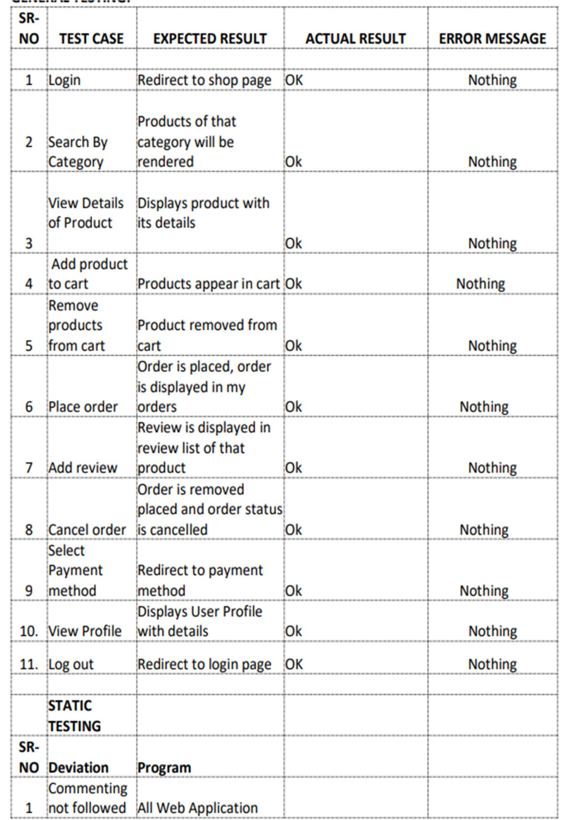

**Chapter 7 : CONSLUSION**

In general, today’s businesses must always strive to create the next best thing that consumers will want because consumers continue to desire their products, services etc. to continuously be better, faster, and cheaper. In this world of new technology, businesses need to accommodate to the new types of consumer needs and trends because it will prove to be vital to their business’ success and survival. E-commerce is continuously progressing and is becoming more and more important to businesses as technology continues to advance and is something that should be taken advantage of and implemented. From the inception of the Internet and e-commerce, the possibilities have become endless for both businesses and consumers. Creating more opportunities for profit and advancements for businesses, while creating more options for consumers. However, just like anything else, e-commerce has its disadvantages including consumer uncertainties, but nothing that can not be resolved or avoided by good decision-making and business practices.

## Chapter 8: BIBLIOGRAPHY

* + https:/[/www.tutorialspoint.com/index.htm](http://www.tutorialspoint.com/index.htm)
  + https:/[/www.javatpoint.com](http://www.javatpoint.com/)
  + https:/[/www.w3schools.com](http://www.w3schools.com/)
  + https://html.com
  + https:/[/www.google.com](http://www.google.com/)